**HEMP**

**HERO**

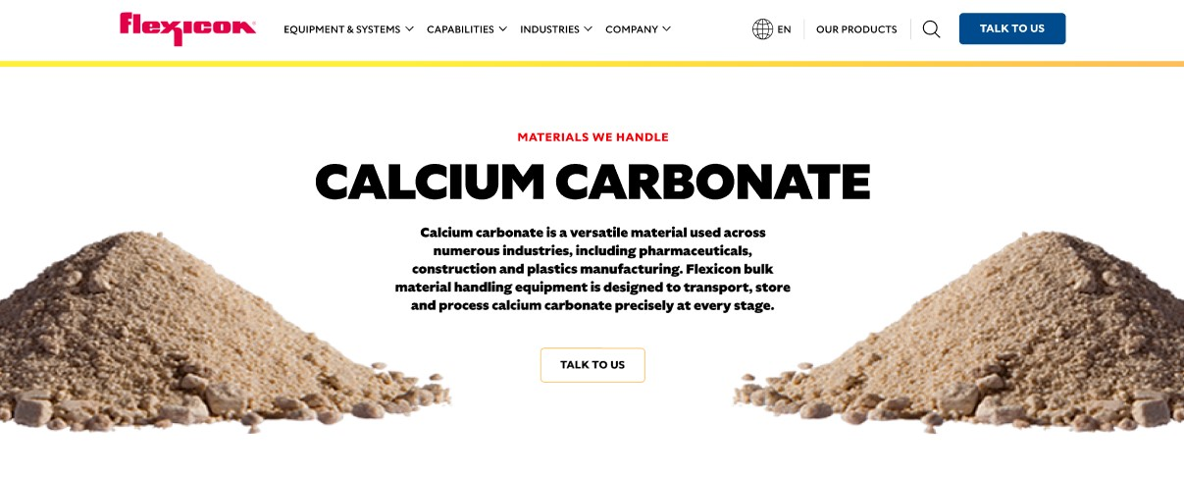

Hemp is a renewable, multi-purpose crop grown for its fiber, seeds, and flowers. Used in everything from textiles to foods and nutraceuticals, it demands careful handling during processing. Flexicon bulk material handling equipment ensures hemp is transported, stored, and processed efficiently and safely.

**Button**: Talk To Us

**SHELF #1 - PRODUCT DESCRIPTION**

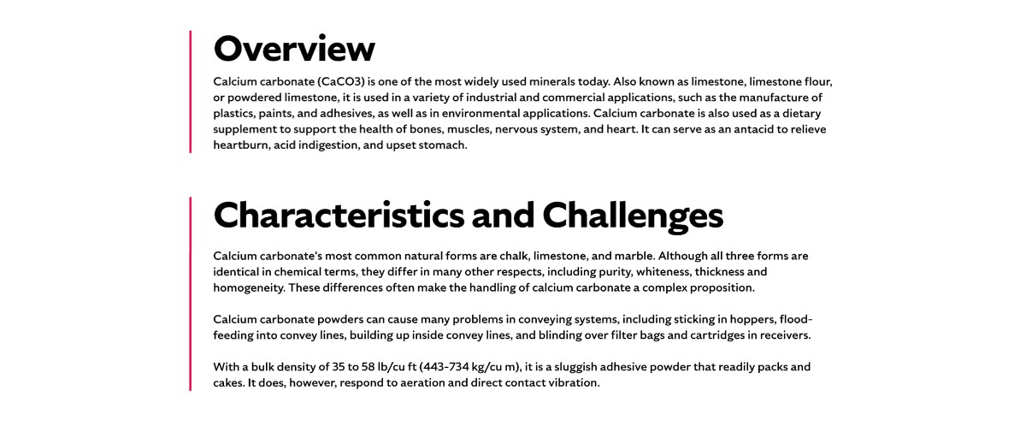

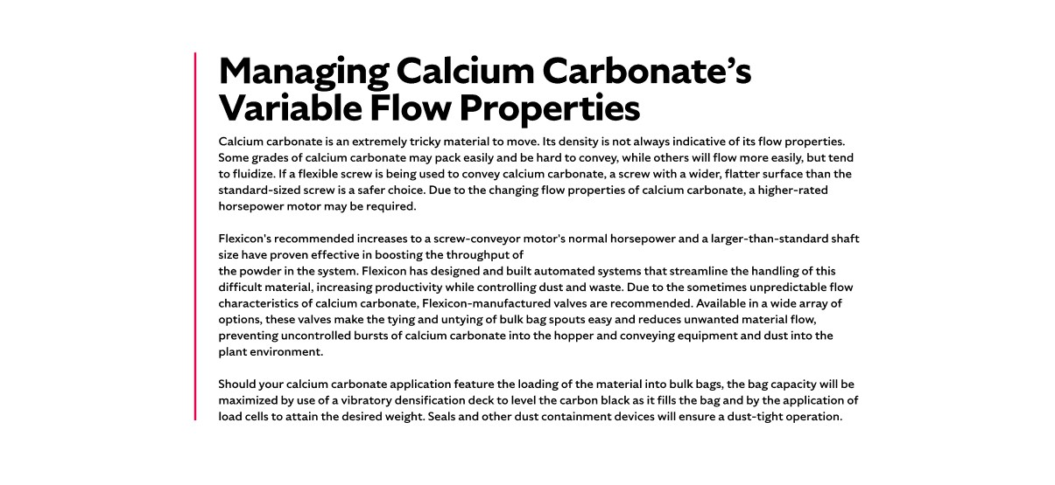

* **Overview**Industrial hemp, a strain of *Cannabis sativa*, has been cultivated for thousands of years for paper, textiles, rope, and more. Today, it is used in a wide range of products, including foods, nutraceuticals, beauty items, insulation, biodegradable packaging, and construction materials. While hemp shares a genetic ancestry with marijuana, it contains less than 0.3% THC, the psychoactive compound. Legalized as an agricultural commodity under the 2018 Farm Bill, hemp production is now growing across the United States.
* **Characteristics and Challenges**Hemp consists of fibrous bast fibers surrounding a woody core known as hurds, which can be used in textiles, composites, animal bedding, and construction materials. Hemp seeds are pressed for oil and cannabidiol (CBD), or ground into flour and feed. Stalks, flowers, and seeds have irregular shapes and bulk densities, typically 10–12 lb/ft³ (160–192 kg/m³), and stalks and flowers can interlock, requiring careful handling to avoid plugging or binding equipment.  
    
  Hemp can be difficult to handle due to its irregular shapes, lightweight stalks, and interlocking fibrous nature, which can cause plugging or binding in convey lines and equipment. Seeds and flowers are friable and may degrade if conveyed too quickly or roughly, while fine particles can create dust that requires containment. Equipment used in food, nutraceutical, or personal care applications must meet strict hygienic standards. When unloading from bulk bags or containers, narrow openings and uneven flow can make complete evacuation challenging, often requiring flow promotion devices, vibratory hoppers, or sealed systems to ensure safe and efficient handling.

**SHELF #2 - FLEXICON SOLUTIONS**

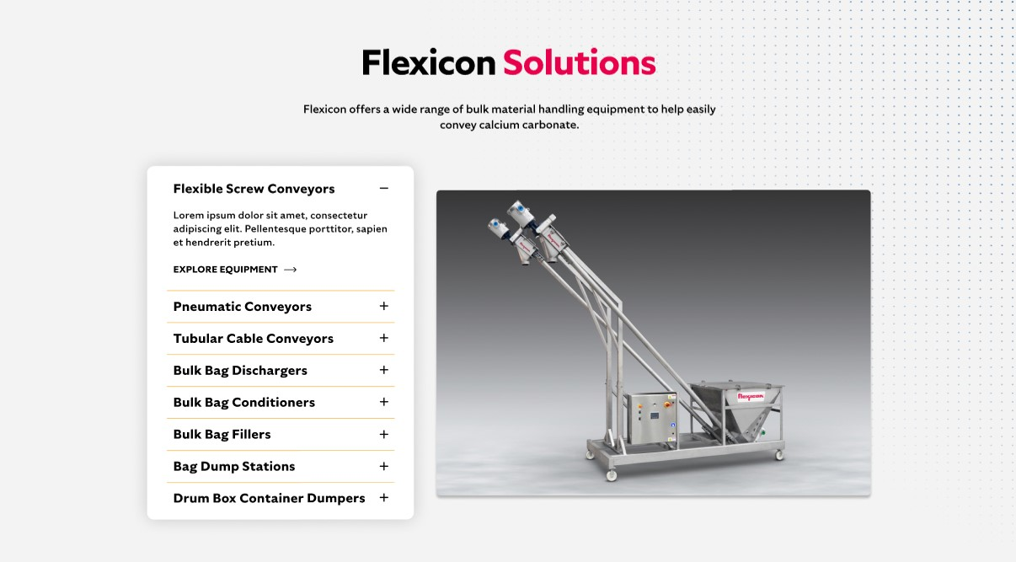

**Flexicon Solutions**

Flexicon offers a wide range of bulk material handling equipment to help easily convey calcium carbonate.

* **Flexible Screw Conveyor**: Move hemp gently while preventing degradation
* **Pneumatic Conveyors**: Transport hemp efficiently through sealed air lines.
* **Tubular Cable Conveyors**: Handle fibrous hemp stalks without clogging.
* **Bulk Bag Dischargers**: Empty hemp from bags safely and completely.
* **Bulk Bag Conditioners**: Promote consistent hemp flow from all bag corners.
* **Bulk Bag Fillers**: Fill bags while containing dust and optimizing capacity.
* **Bag Dump Stations**: Allow safe manual unloading of hemp into hoppers.
* **Drum Box Container Dumpers**: Efficiently transfer hemp from smaller containers.

**SHELF #3: LIFETIME PERFORMANCE GUARANTEE**

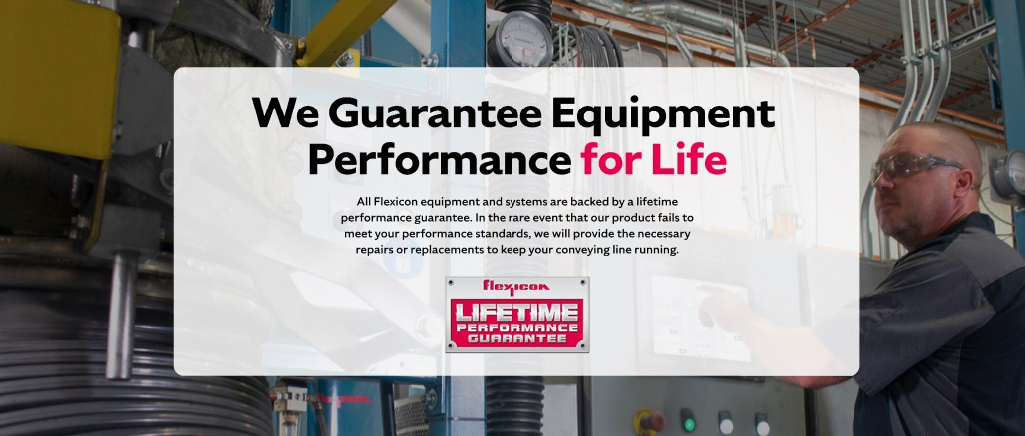

**Lifetime Performance Guarantee**

All Flexicon equipment and systems are backed by a lifetime performance guarantee. In the rare event that our product fails to meet your performance standards, we will provide the necessary repairs or replacements to keep your conveying line running.

**SHELF #4: CASE STUDIES**

